## **Distance Calculation:**

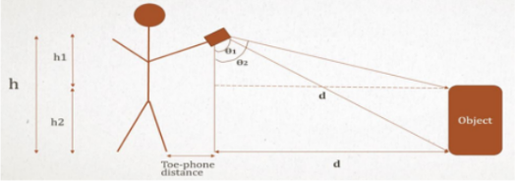

tanθ1 = d/h => d = h ∗ tanθ1

Actual Distance= h ∗ tanθ1 + toe – phonedistance

<https://www.digikey.com/en/articles/using-an-accelerometer-for-inclination-sensing>

Object Height and Width:

Bitmap b = ((BitmapDrawable)imageView.getBackground()).getBitmap();

int w = b.getWidth();

int h = b.getHeight();

rect.width()

rect.height()

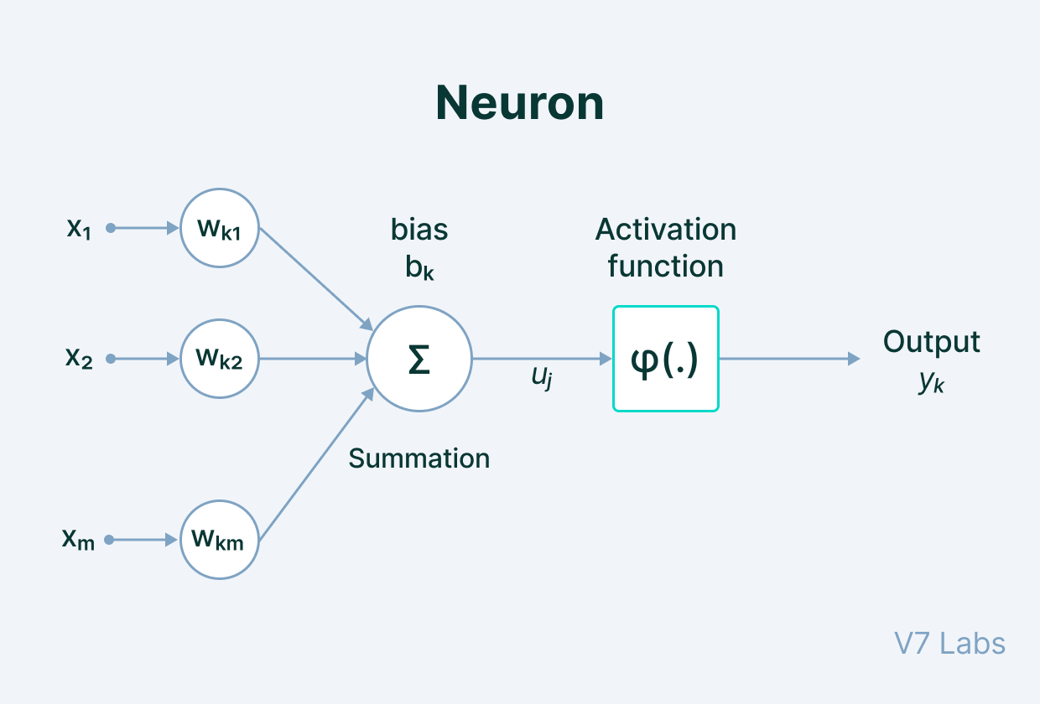

**Input**- It is the set of features that are fed into the model for the learning process. For example, the input in object detection can be an array of pixel values pertaining to an image.

**Weight**- Its main function is to give importance to those features that contribute more towards the learning. It does so by introducing scalar multiplication between the input value and the weight matrix. For example, a negative word would impact the decision of the sentiment analysis model more than a pair of neutral words.

**Transfer function**- The job of the transfer function is to combine multiple inputs into one output value so that the activation function can be applied. It is done by a simple summation of all the inputs to the transfer function.

**Activation Function** - It introduces non-linearity in the working of perceptrons to consider varying linearity with the inputs. Without this, the output would just be a linear combination of input values and would not be able to introduce non-linearity in the network.

**Bias**- The role of bias is to shift the value produced by the activation function. Its role is similar to the role of a constant in a linear function.

When multiple neurons are stacked together in a row, they constitute a layer, and multiple layers piled next to each other are called a multi-layer neural network.

We've described the main components of this type of structure below.

